**Exp No:7**

**Practice Queries using ANY, ALL, IN, EXISTS, UNION, INTERSECT**

**#Any**

select * from boats;

select BCOLOR from boats

where BID = ANY (select BID from reserves where day='2018-01-27');

**Output:**

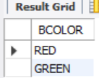

**#All**

select all BNAME from boats where true;

**Output:**

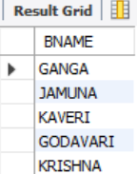

**#Exists**

select BNAME from boats

where Exists

(select RATING from sailors where sailors.SID = boats.BID and RATING >= 8);

**Output:**

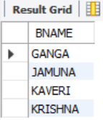

**#in**

select * from boats

where BCOLOR in ('PINK' , 'BLUE');

**Output:**

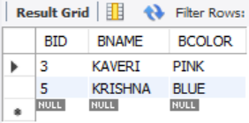

**#union**

select BNAME from boats union select SNAME from sailors;

**Output:**

